Laboratory for pupils

10-14 years

A Guide for Teachers
material
Material provided by us:
- Film Perpetuum Mobile
- Dokument FuchsDumontCorni_UNIMORE_2019 (for teachers)
- Dokument Hydrogen_Fuel_Cells (for teachers)
- Potato battery guide
- Solar cell guide
- Fuel cell guide
Material that the school has to purchase itself:
For the potato battery:
- potatoes
- zinc platelets
- copper platelets
- LED
- Insulated copper wire
- chopping board
- knives
Fort he solar cell:
- A powerful photo lamp
- solar cell
- ventilator
- Black paper
- Screwdrivers
For the fuel cell:
- Construction kit with a model of a hydrogen fuel cell
- Distilled Water
procedure
1. First read the document Hydrogen_Fuel_Cells. Watch the film Perpetuum Mobile and read the paper FuchsDumontCorni_UNIMORE_2019 with comments to the movie.
2. Watch the film Perpetuum Mobile together with your students and analyze the energy carriers at work. (see film Perpetuum Mobile and FuchsDumontCorni_UNIMORE_2019). You can use the poster forces of nature or the cards forces of nature and a blackboard.
4. Carry out the experiment with the potato battery (see potato battery instructions).
5. The students should now fill out the worksheet (see potato battery worksheet). Discuss with them which forces of nature are at work in the potato battery. You can use the poster forces of nature or the cards forces of nature.
6. Carry out the experiment with the solar cell (see solar cell guide).
7. The students should now fill in the worksheet (see solar cell worksheet). Discuss with them which forces of nature are at work in the solar cell. You can use the poster forces of nature or the cards forces of nature.
8. Carry out the experiment with the fuel cell (see fuel cell guide).
9. The students should now fill out the worksheet (see fuel cell worksheet). Discuss with them which forces of nature are at work in the solar cell. You can use the poster forces of nature or the cards forces of nature.

Tips for teachers

Perpetuum Mobile Movie
Start with the movie perpetuum mobile and discuss the ghosts, which appear in the movie. The kids usually recognize quickly electricity, heat, rotation and light. Draw them on the blackboard and name them correctly. You can also use the cards if you don’t have a blackboard. Also add copper and zinc, because we will need them for the potato battery.
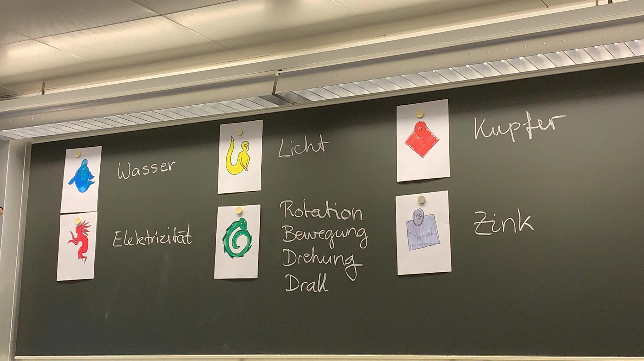

… and hydrogen and oxygen for the fuel cell:
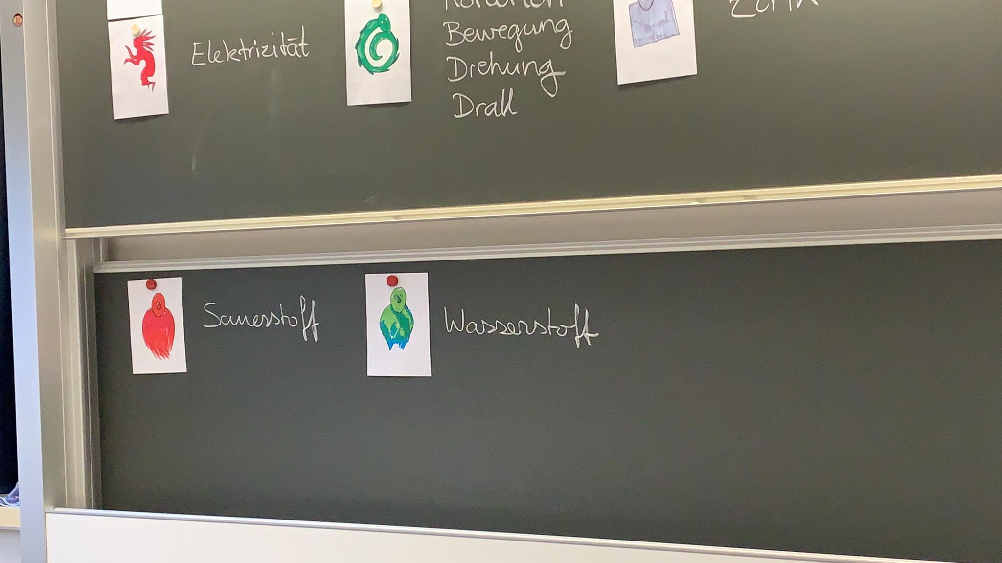

Potato battery

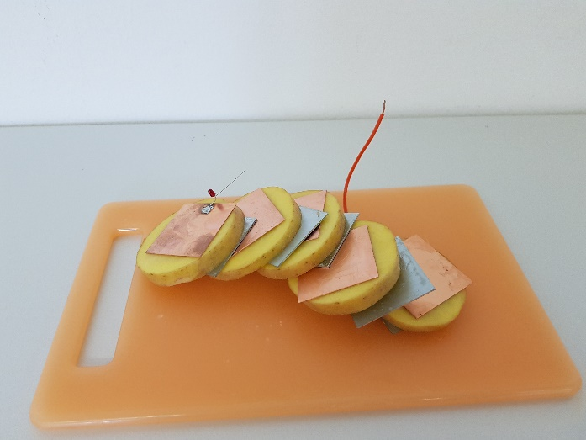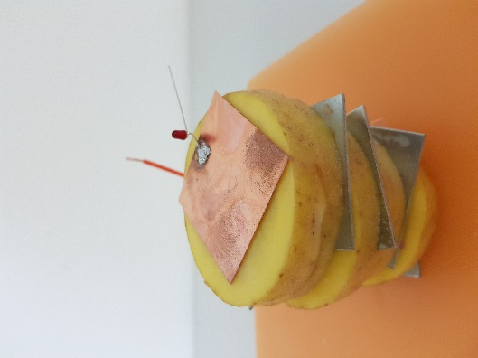

buildup
The potato battery consists of zinc plates, copper plates, potato, LED and copper wires. You should observe that the LED lights up.
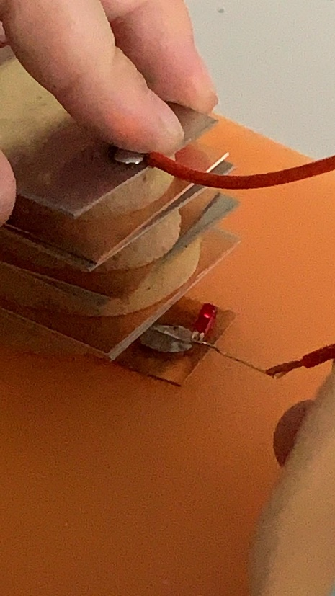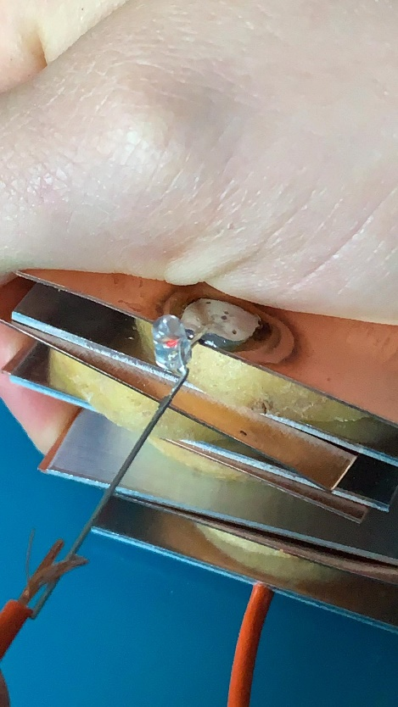

How it works
Zinc, copper and potato juice are energy carriers (chemical substances). The reaction of zinc, copper and potato juice releases energy. In a battery, the energy provided is used to pump electricity (electrical charge) from a lower to a higher electrical level and to build up an electrical voltage. When zinc, copper and potato juice react, they disappear. New chemical substances appear in their place. As a result of the reaction, the electricity (electric charge) is pumped to a voltage.
Ask students to choose the ghosts from their card stack, which are at work in the battery.
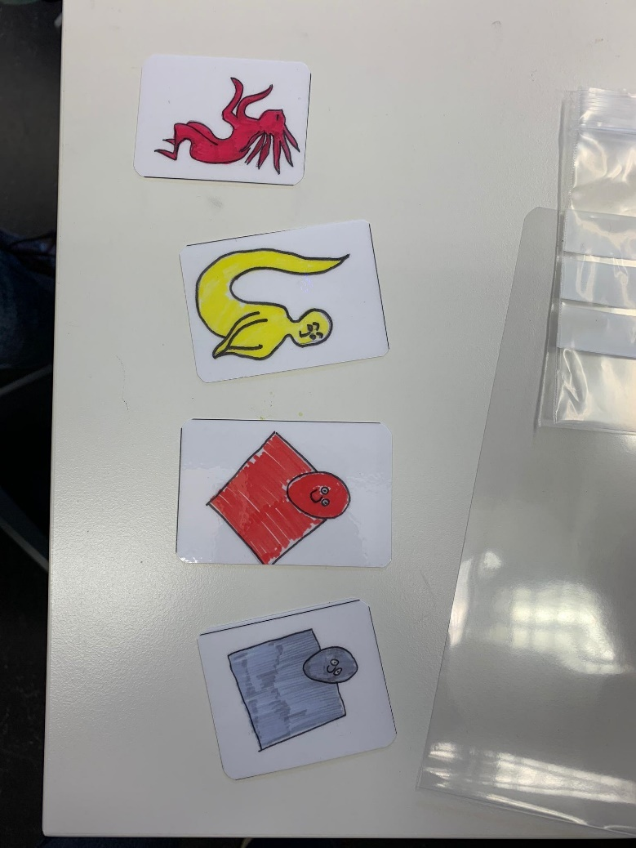

They are electricity, light, copper and zinc. Then ask the students what the ghosts do in the battery and which ghosts wakes up the other, how the energy is transferred from one ghost to the other. Let them write and draw
“Copper and zinc give their energy to the electricity. The electricity gives its energy to the light.”

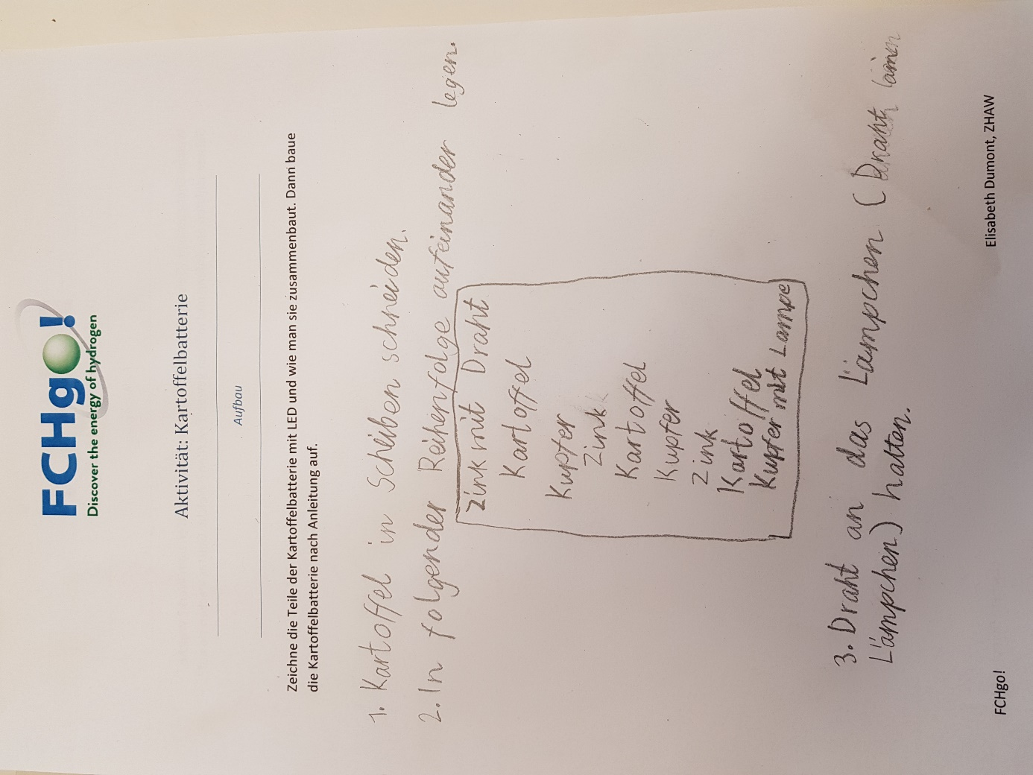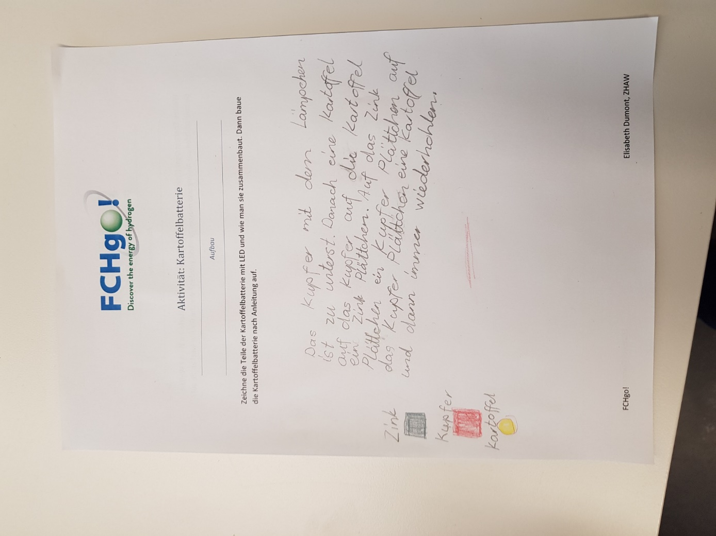
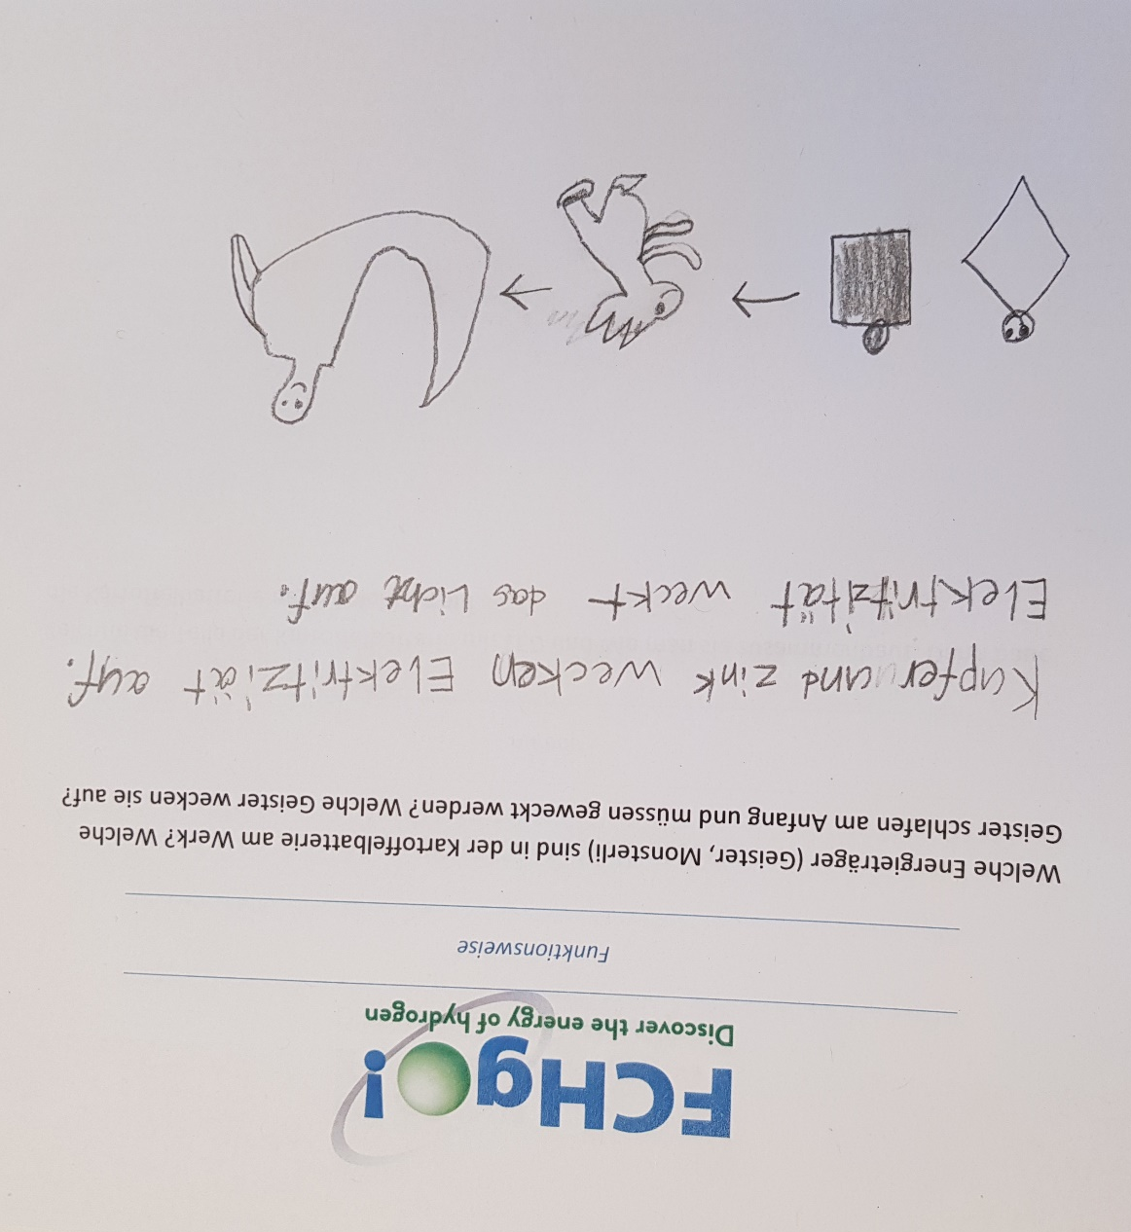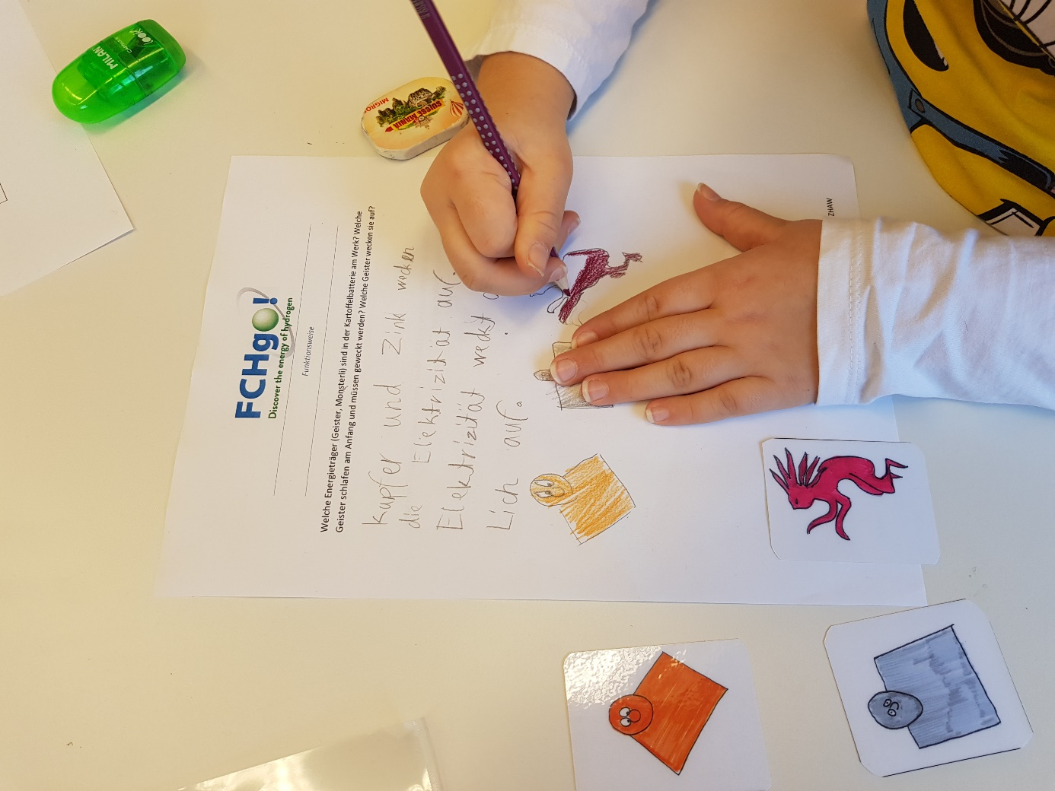

Solar Cell

Buildup
The solar cell kit consists of a solar cell, copper wires and a fan (electric motor with fan).

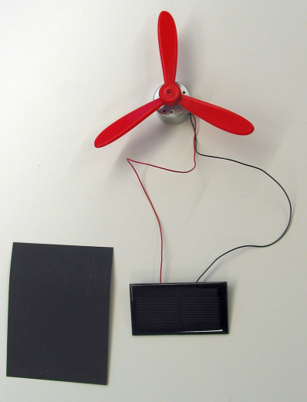

How it works
In a solar cell, light and electricity are at work as energy carriers. Sunlight carries a lot of energy, which is made available when the light falls on solar cells (photovoltaic cells or PV cells) and is absorbed by them. The light actually disappears like a chemical substance in the reaction, but it leaves its energy behind. The energy provided is used to separate positive and negative electricity in the cells and thus build up an electrical voltage. The charge then flows through the circuit and gives off its energy to the movement in the fan. Movement is also an energy carrier. The fan starts to rotate.
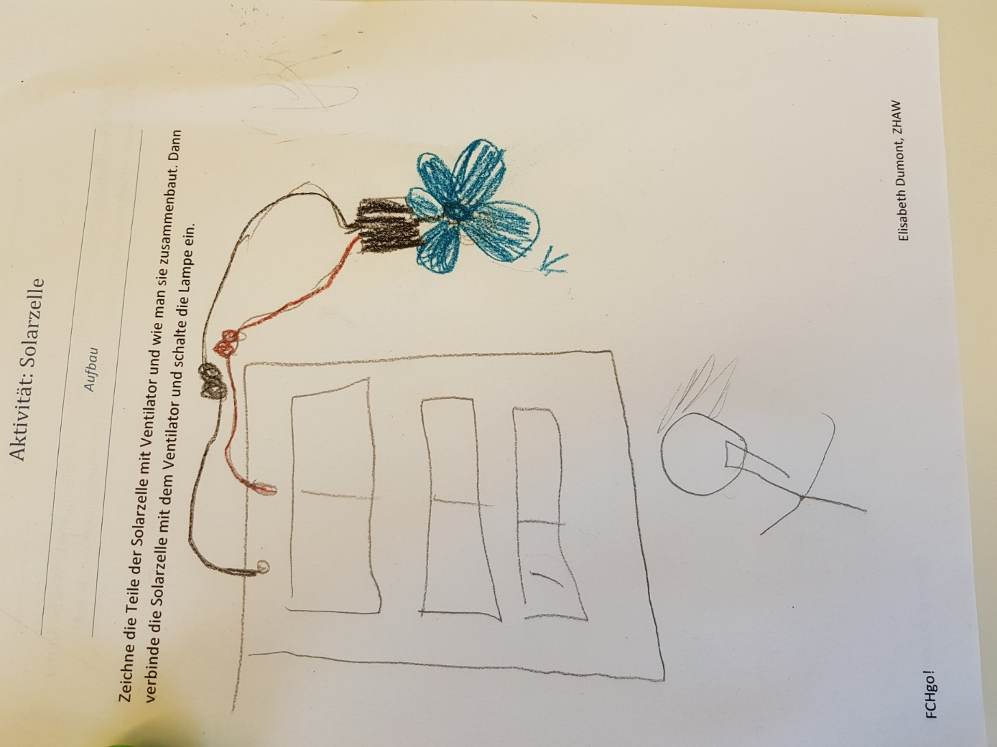
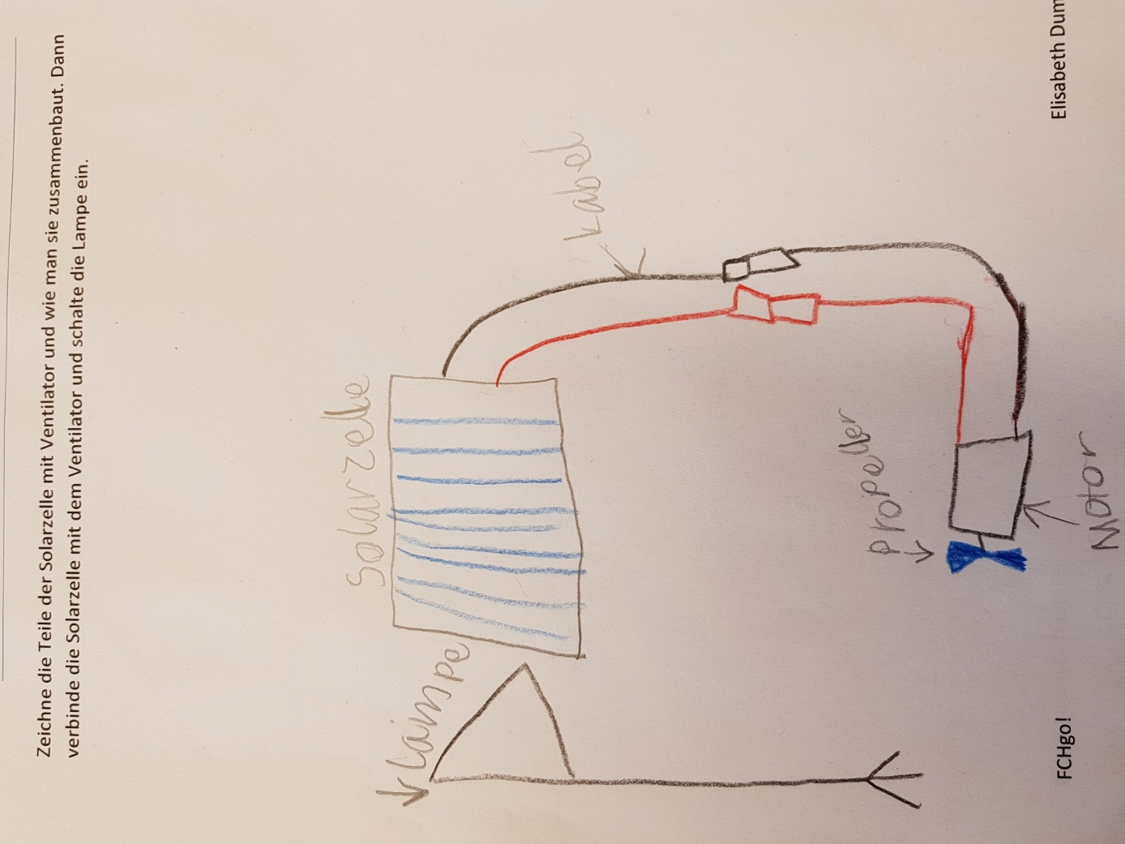
“Light wakes up electricity. Electricity wakes up motion. Heat is produced everywhere.”
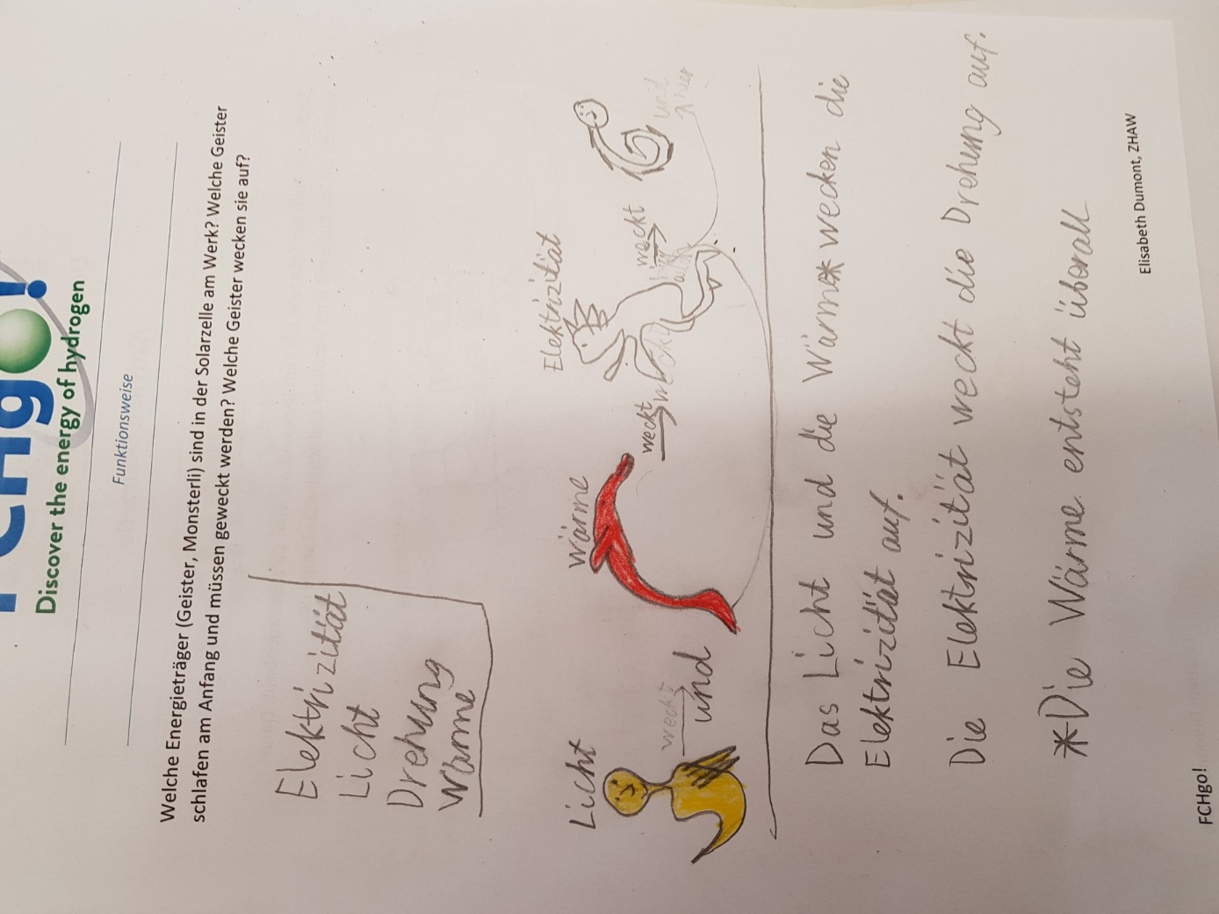

3)Fuell cell

Buildup
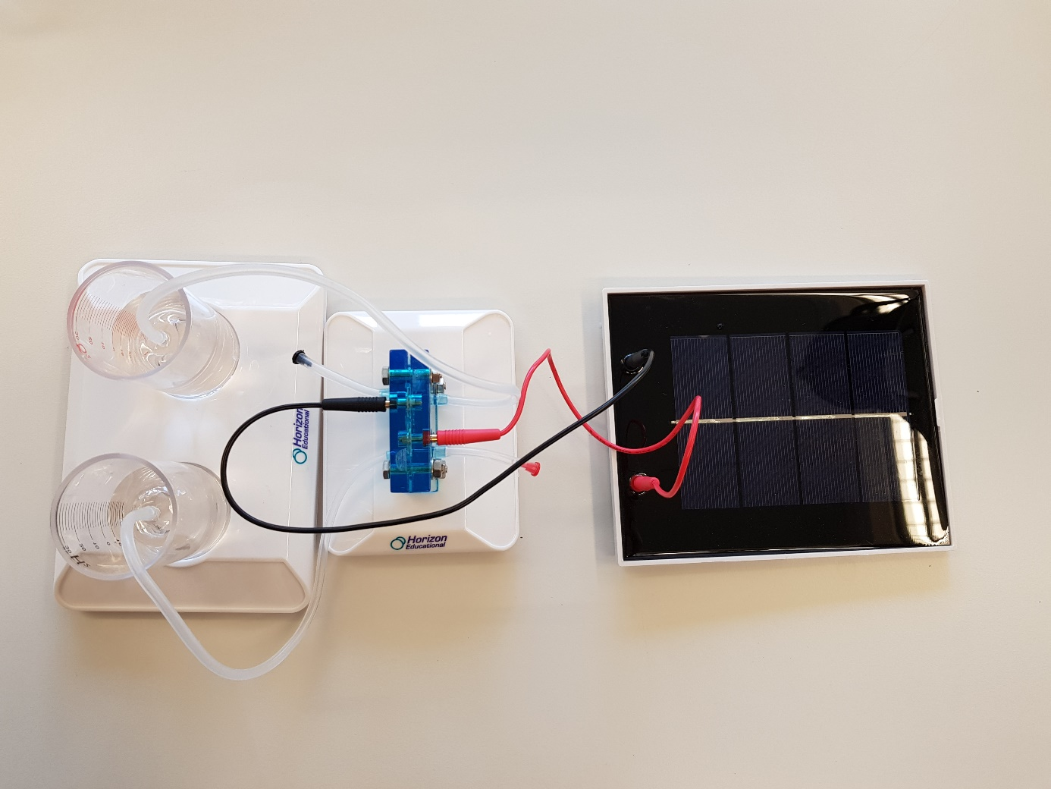
The relevant components are:
- Solar cell
- hydrogen fuel cell
- Hydrogen and oxygen tanks
- water tank
- electric motor
- ventilator
The hydrogen fuel cell is connected to the water tank as well as to hydrogen and oxygen tanks via hoses. The hydrogen cell can be connected to the photovoltaic panel with two electrical cables.
After hydrogen and oxygen production, a fan was connected to the fuel cell and the kids observed that the fan rotated as long as there was some gas present in the tanks.
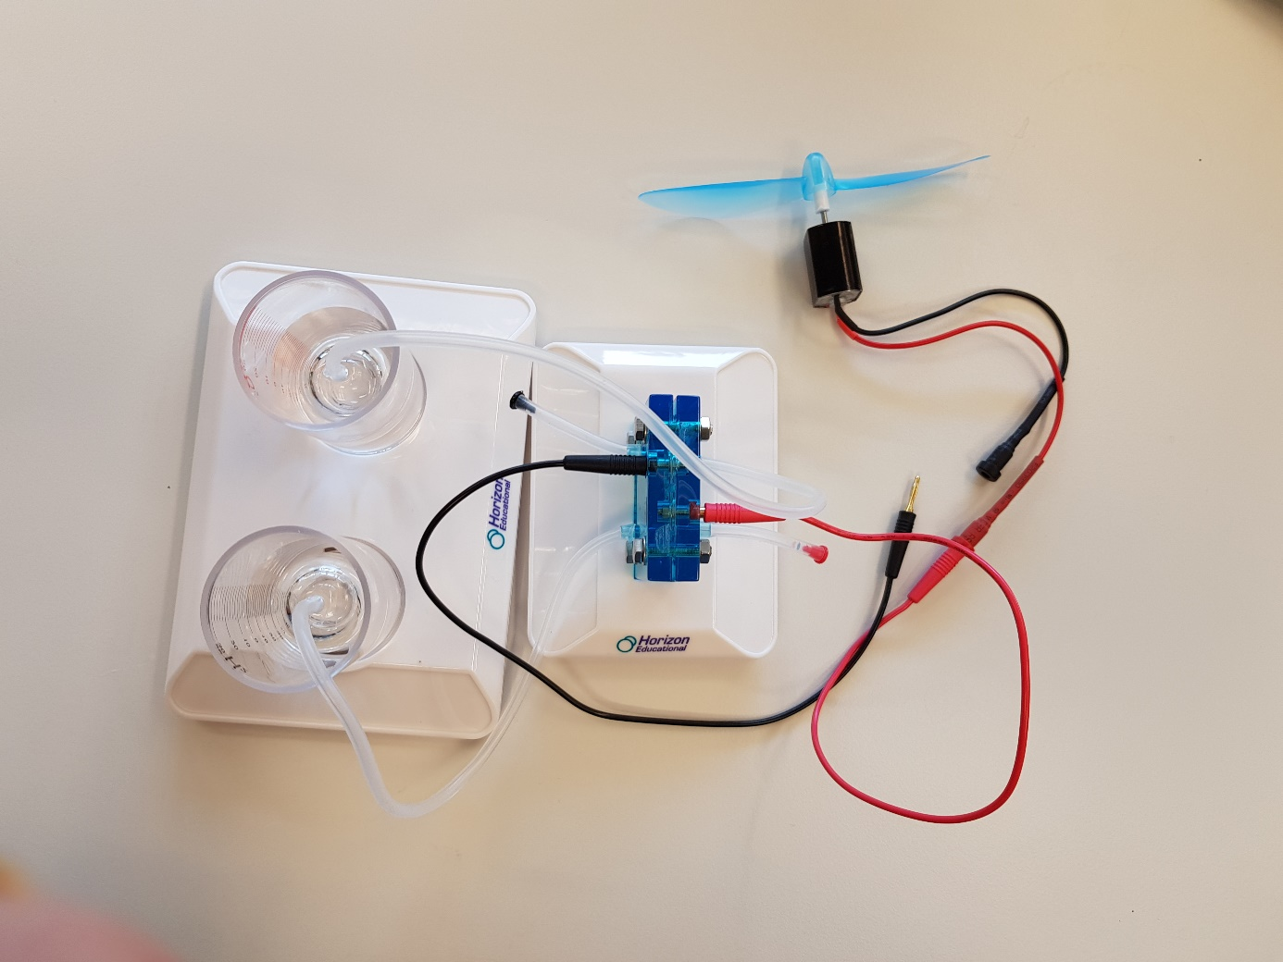

How it works
The system can be analyzed in two ways: Charging and Discharging
At the centre is the hydrogen fuel cell, which, when powered by the solar panel, charges a "chemical accumulator" that separates hydrogen and oxygen produced by the electrolysis of water. When the cell is connected to the electric motor, the "chemical accumulator" is discharged (i.e. hydrogen and oxygen are brought together again) and electricity circulates, which makes the motor run, which in turn moves the fan.

Charging process
A regenerative energy system for FCH technology typically begins with our sun. If we want electricity for hydrogen production, a direct way is photovoltaic solar cells that are exposed to sunlight and build up an electrical voltage that drives the following processes.
The mechanism of solar cells with light, electricity and heat as carriers and means works as follows. Sunlight carries a lot of energy that is made available when the light falls on and is absorbed by solar cells (photovoltaic cells or PV cells). The light actually disappears like a chemical substance in the reaction, but it leaves its energy behind. The energy provided is used to separate positive and negative electricity in the cells and thus build up an electrical voltage. If allowed, the charge flows through an electric circuit, such as an electrolysis cell, in which hydrogen is produced from water, to our PV power plant.
We need hydrogen that can be extracted from water. To produce hydrogen from water, we need to direct the spontaneous reaction that produces water from hydrogen and oxygen in the opposite direction - we need energy provided by electricity. The process that does this is called electrolysis.

Discharging
The reaction of hydrogen with oxygen, which produces water, provides energy. In a fuel cell, the energy provided is used to pump electrical charge from a lower to a higher electrical level and to build up an electrical voltage. When hydrogen gas reacts with oxygen gas, the two gases disappear. Water appears in their place. As a result of the reaction, the charge is pumped.
The chemical tension between the combination of hydrogen and oxygen on the one hand and water on the other is so high that the reverse conclusion does not occur - water does not spontaneously decompose into hydrogen and oxygen. To achieve this, we can let the power of electricity help by providing energy.

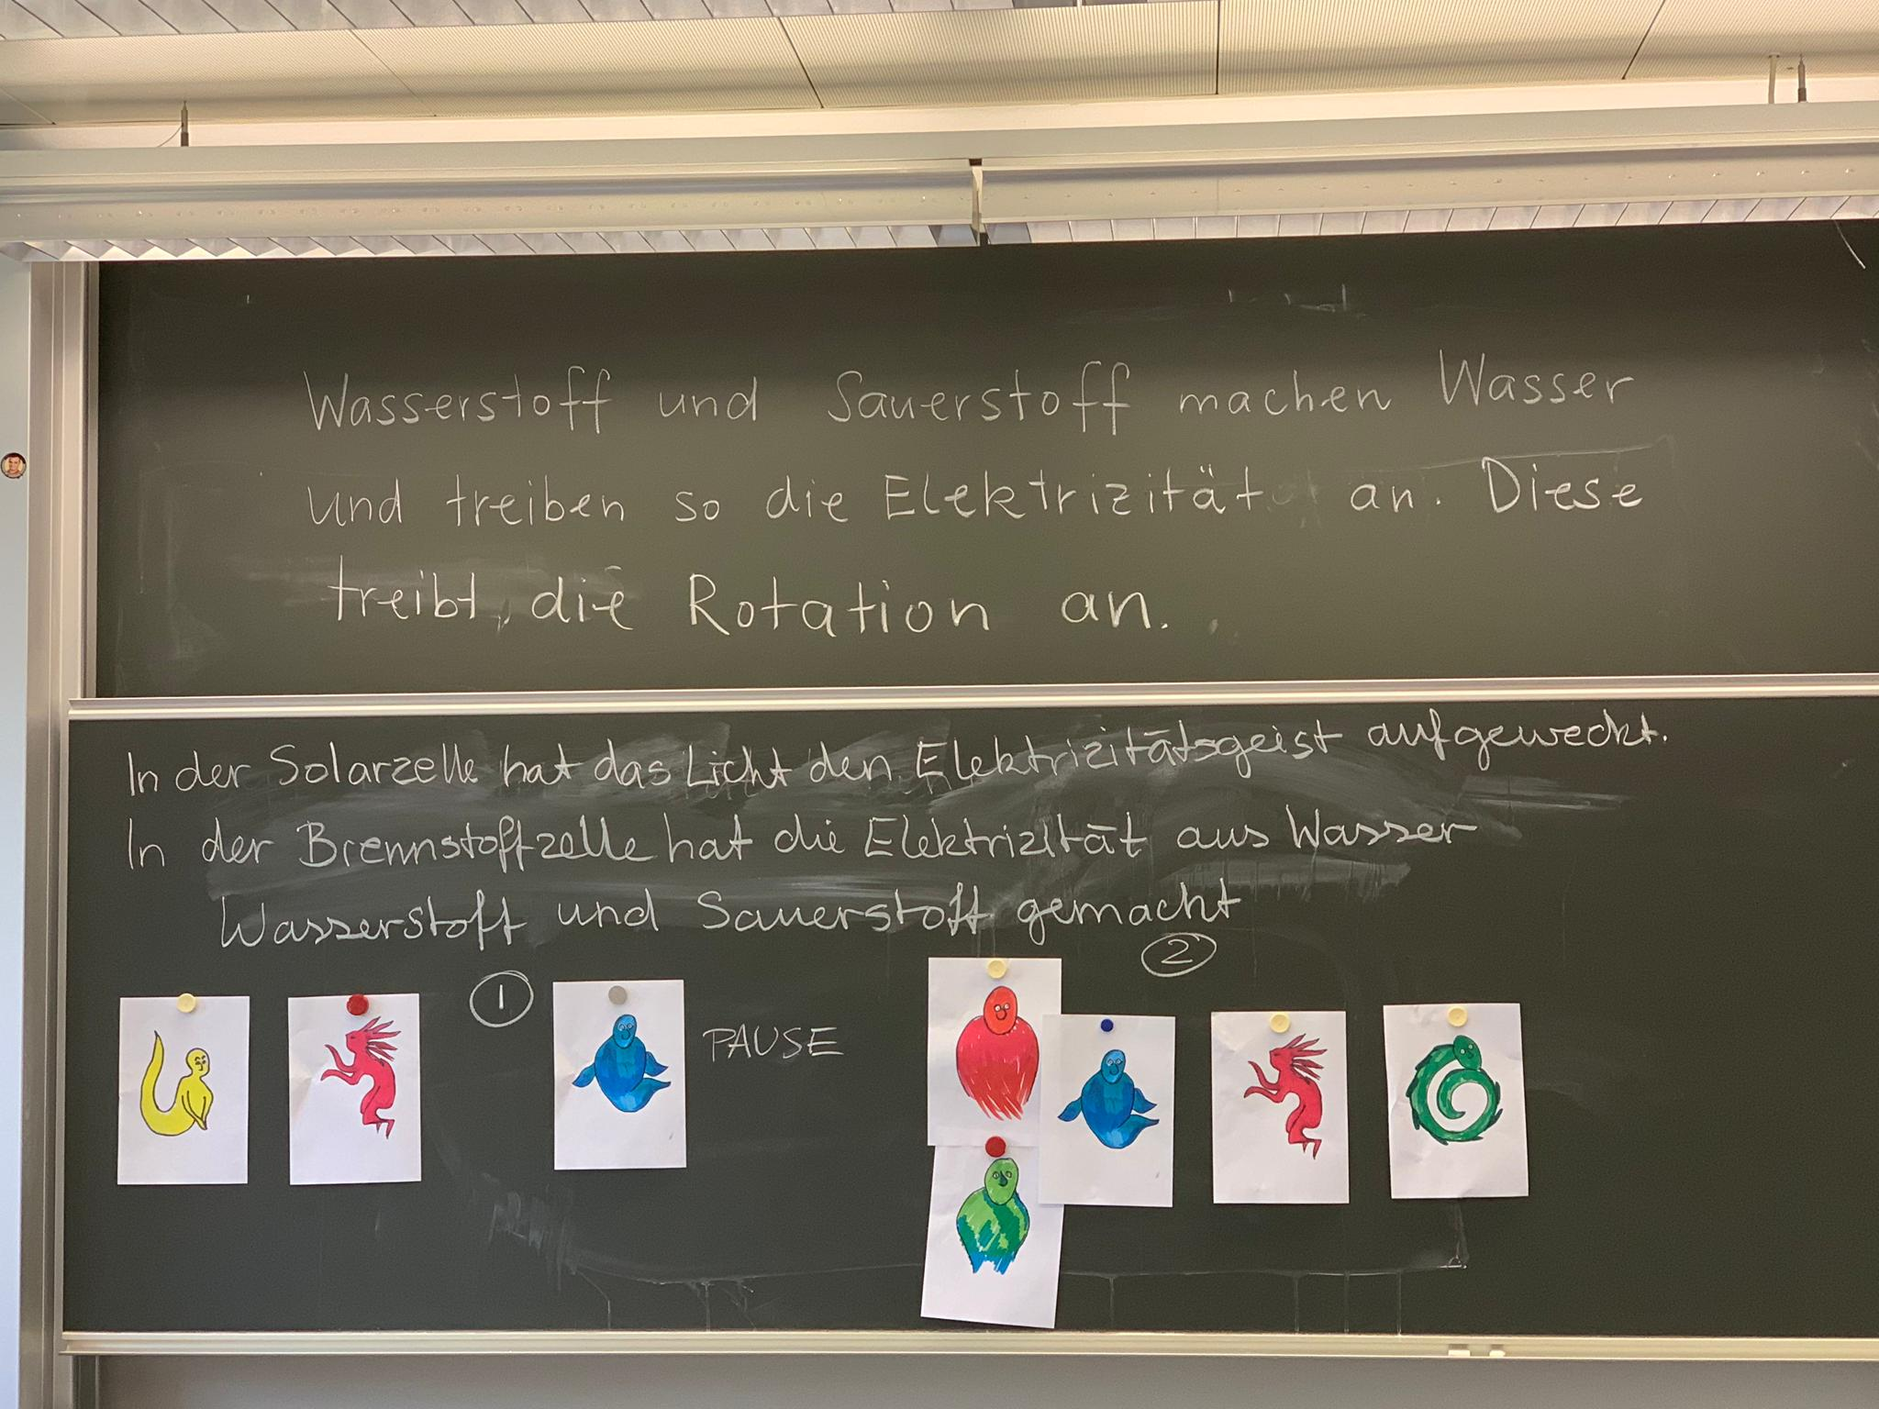
Ask the students to identify the ghosts and tell what they do in the electrolyzer.
“In the solar cell, light wakes up the electricity. In the fuel cell (we used a reversible fuel cell, that worked here as an electrolyzer), electricity produces oxygen and hydrogen out of water. In the fuel cell hydrogen and oxygen make water and they drive electricity. Electricity drives the rotation. “

