Potato Battery Instructions

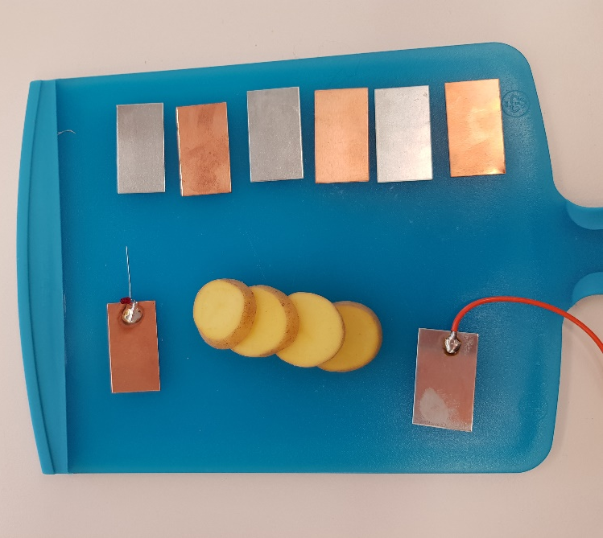 | Material:  - Cut potato into thin slices (3-4 mm), for better results use a mandoline slicer.  - Zinc and copper plates  - LED  - wire

The potato should always be in between a copper and zinc plate. Start with a zinc plate with a wire soldered onto it. Then take a potato slice and a copper plate
On top of the copper plate comes a gain a zinc plate.
And a potato. Always use the same sandwich structure: zinc, potato, copper.
On top the last potato slice put a copper plate with a LED and close the circuit with the wire.

