Fuel Cell Instructions

 | First look at the fuel cell. This is a reversible fuel cell. It has two connectors: A black connector for hydrogen...
 | …an a red one for oxygen.
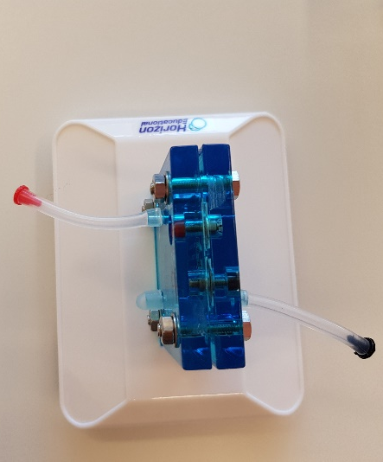 | This is a reversible fuel cell. It functions as an electrolyzer and as a fuel cell
 | Then there are two tanks: one with a red label for oxygen and one with a black label for hydrogen.
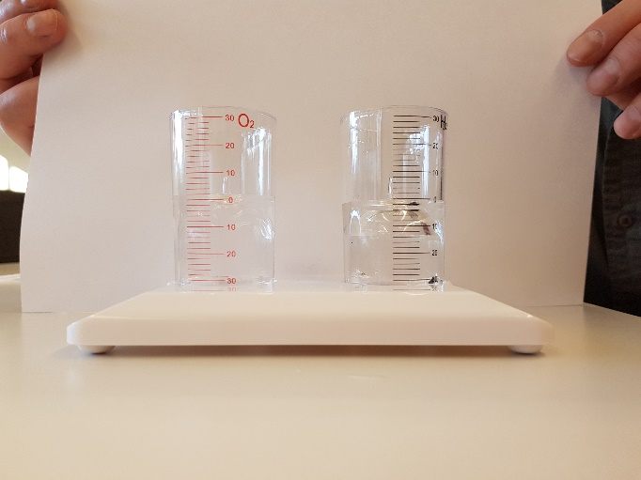 | Fill the two tanks with distilled water to zero. Turn the inner tanks while doing so until they are also filled with water.
Then put a hose over the connection in the inner container.

Check your setup before you continue!
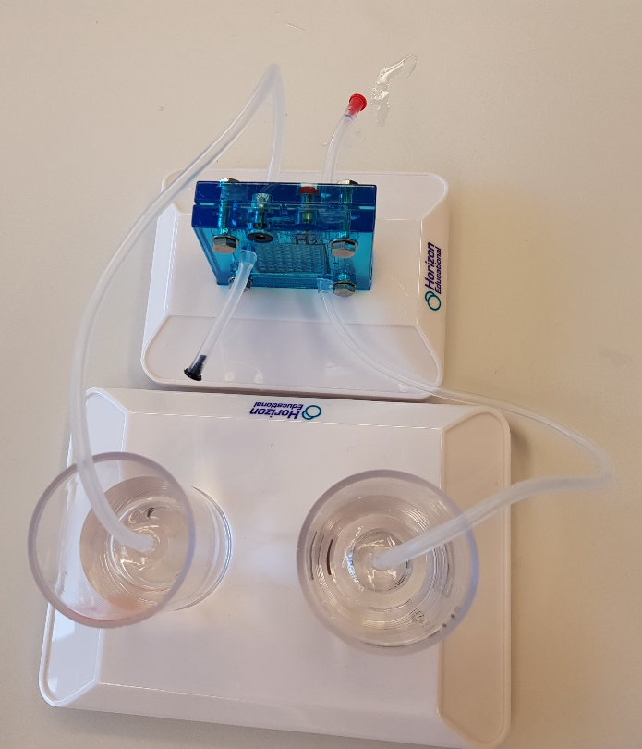 | Take a hose and connect the black side of the fuel cell to the tank with the black label.  Take the second hose and connect the red side of the fuel cell to the tank with the red label.  Now hydrogen and hydrogen should be connected, as well as oxygen with oxygen.  Check your setup before you continue!
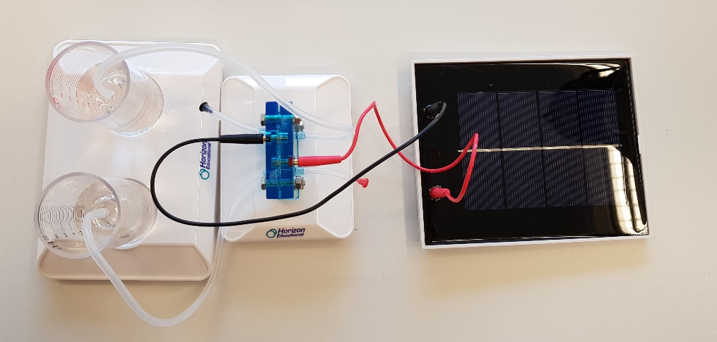 | Now you take the two cables and connect the red cable with the fuel cell and the solar cell. Then connect the black cable to the fuel cell and the solar cell.  Check your setup before you continue!
 | When you switch on the lamp, you should observe that the hydrogen tank and the oxygen tank fill with gas.
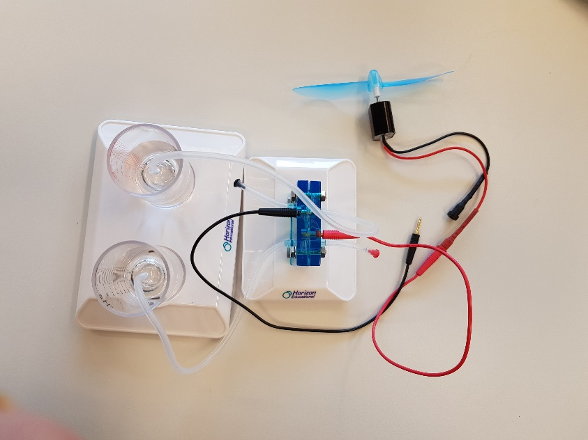 | When the hydrogen tank is full, you will see bubbles rising in the water. Now you can switch off the lamp and take the solar cell off. Instead of the solar cell you can attach the fan to the wires. It should turn. Now you observe that the gas tanks are emptying. The fan will turn slower and slower and when the tanks are completely empty, stop turning.

